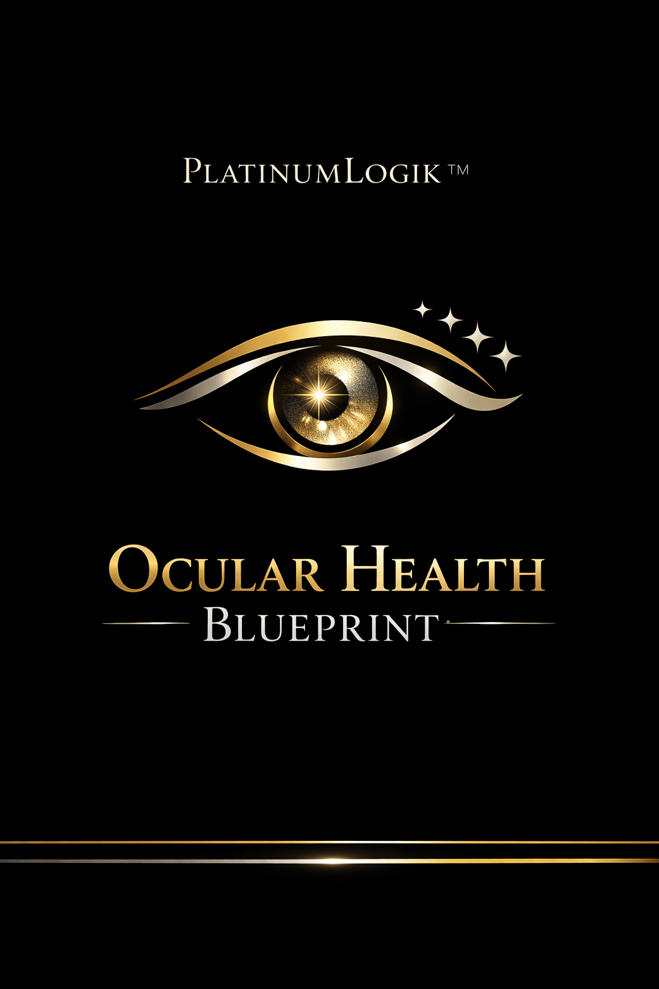
PlatinumLogik™ Ocular Health Cookbook
25 Whole-Food Recipes for Eye Support + Clearer-Feeling, Better-Looking Eyes

25 Recipes
Golden Egg & Greens Skillet
Eye-support angle: Egg yolk lutein/zeaxanthin + leafy greens for macular pigment support.
Servings: 2 | Prep: 8 min | Cook: 10 min
Ingredients:
- 2–3 eggs
- 2 cups spinach or kale
- 1 tbsp olive oil
- 1/4 tsp turmeric
- 1 clove garlic, minced
- Salt + black pepper
- Optional: 1/4 avocado, sliced
Method:
1. Warm olive oil; sauté garlic 30 seconds.
2. Add greens; cook until wilted.
3. Crack eggs in, add turmeric, salt, pepper.
4. Cover until whites set; finish with avocado if using.
Key nutrients: lutein, zeaxanthin, vitamin A precursors, vitamin E, healthy fats

Berry-Citrus Chia Bowl
Eye-support angle: Vitamin C + polyphenols + omega-3 precursors for oxidative balance and tear support.
Servings: 2 | Prep: 5 min (+ soak) | Cook: 0 min
Ingredients:
- 3 tbsp chia seeds
- 1 cup unsweetened milk of choice
- 1 cup mixed berries
- Zest + juice of 1/2 orange
- 1 tbsp crushed walnuts
- Optional: cinnamon
Method:
1. Mix chia with milk; refrigerate 20–30 min (or overnight).
2. Top with berries, orange zest/juice, walnuts, cinnamon.
Key nutrients: vitamin C, anthocyanins, ALA omega-3, fiber

Smoked Salmon Avocado Toast (Rye or Whole-Grain)
Eye-support angle: Omega-3 + vitamin E + carotenoids to support surface comfort and visual function.
Servings: 2 | Prep: 8 min | Cook: 0 min
Ingredients:
- 2 slices whole-grain or rye bread
- 1/2 avocado
- 3–4 oz smoked salmon
- Lemon squeeze
- Dill or chives
- Black pepper
Method:
1. Toast bread.
2. Mash avocado with lemon and pepper.
3. Top with salmon and herbs.
Key nutrients: omega-3s, vitamin E, selenium, protein

Carrot-Ginger Oatmeal
Eye-support angle: Beta-carotene + antioxidant spices in a steady-energy breakfast.
Servings: 2 | Prep: 5 min | Cook: 10 min
Ingredients:
- 1 cup rolled oats
- 2 cups water or milk
- 1 cup grated carrot
- 1 tsp fresh grated ginger
- 1/2 tsp cinnamon
- 1 tbsp pumpkin seeds
- Optional: raisins
Method:
1. Simmer oats with liquid.
2. Stir in carrot, ginger, cinnamon for last 3–4 minutes.
3. Top with pumpkin seeds (and raisins if using).
Key nutrients: beta-carotene, zinc, fiber

Green Smoothie (Macula Blend)
Eye-support angle: Lutein/zeaxanthin + vitamin C + hydration-friendly blend.
Servings: 2 | Prep: 6 min | Cook: 0 min
Ingredients:
- 2 cups spinach
- 1 frozen banana
- 1 kiwi
- 1/2 cup pineapple
- 1 tbsp ground flaxseed
- 1–1.5 cups water
Method:
1. Blend until silky.
2. Serve immediately; add more water for a lighter texture.
Key nutrients: lutein, vitamin C, ALA omega-3

Greek Yogurt + Pistachio + Mango Cup
Eye-support angle: Protein + carotenoids + vitamin E for tissue support.
Servings: 2 | Prep: 5 min | Cook: 0 min
Ingredients:
- 1.5 cups plain Greek yogurt
- 1/2 cup diced mango
- 2 tbsp pistachios
- 1 tsp honey (optional)
Method:
1. Layer yogurt, mango, pistachios.
2. Drizzle honey if desired.
Key nutrients: protein, lutein, vitamin C, vitamin E

Sardine & Lemon Herb Bowl
Eye-support angle: Omega-3 powerhouse with greens and citrus for eye surface + antioxidant support.
Servings: 2 | Prep: 10 min | Cook: 0 min
Ingredients:
- 2 tins sardines in olive oil
- 3 cups arugula or spinach
- 1/2 cucumber, sliced
- 1/2 cup cherry tomatoes
- Lemon juice
- Capers (optional)
Method:
1. Assemble greens + veg.
2. Top with sardines.
3. Dress with lemon and a splash of sardine olive oil; add capers if using.
Key nutrients: omega-3s, vitamin D, selenium, vitamin C

Salmon Sheet-Pan with Broccoli & Peppers
Eye-support angle: Omega-3 + vitamin C + carotenoids; easy weekly anchor meal.
Servings: 4 | Prep: 10 min | Cook: 15 min
Ingredients:
- 1.5 lb salmon
- 3 cups broccoli florets
- 2 bell peppers, sliced
- 2 tbsp olive oil
- Garlic powder
- Salt + pepper
- Lemon slices
Method:
1. Heat oven to 425°F.
2. Toss broccoli/peppers with olive oil + seasoning.
3. Add salmon; top with lemon.
4. Bake 12–15 min until flaky.
Key nutrients: omega-3s, vitamin C, lutein, zeaxanthin

Mediterranean Lentil & Spinach Stew
Eye-support angle: Zinc + polyphenols + leafy carotenoids in a hearty bowl.
Servings: 6 | Prep: 12 min | Cook: 30 min
Ingredients:
- 1.5 cups lentils
- 1 onion, diced
- 2 carrots, diced
- 3 cloves garlic
- 1 tsp cumin
- 1 tsp smoked paprika
- 6 cups broth
- 4 cups spinach
- Olive oil
Method:
1. Sauté onion/carrots/garlic in olive oil 5 min.
2. Add spices, lentils, broth; simmer 25–30 min.
3. Stir in spinach; season.
Key nutrients: zinc, iron, folate, carotenoids

Kale Caesar (Anchovy-Lemon) with Chicken
Eye-support angle: Kale lutein + omega-3 from anchovy; protein for repair.
Servings: 2 | Prep: 12 min | Cook: 0–12 min
Ingredients:
- 4 cups chopped kale
- 1 chicken breast (optional)
- 1 tbsp anchovy paste or 3 fillets
- 1 tbsp olive oil
- 1 tbsp lemon juice
- 1 tsp Dijon
- Parmesan (optional)
Method:
1. Massage kale with olive oil 1 minute.
2. Whisk anchovy, lemon, Dijon; toss.
3. Add sliced chicken if using; top with parmesan.
Key nutrients: lutein, omega-3s, vitamin C

Tuna + White Bean + Parsley Salad
Eye-support angle: Zinc/selenium + olive oil + herbs for antioxidant support.
Servings: 2 | Prep: 10 min | Cook: 0 min
Ingredients:
- 1 can tuna
- 1 can white beans, rinsed
- 1/2 red onion, thin sliced
- Big handful parsley
- Olive oil
- Lemon juice
- Black pepper
Method:
1. Mix tuna, beans, onion, parsley.
2. Dress with olive oil + lemon; season.
Key nutrients: selenium, zinc, protein, fiber

Sweet Potato + Black Bean Bowl (Citrus Slaw)
Eye-support angle: Beta-carotene + fiber + vitamin C; steady eye-support fuel.
Servings: 3 | Prep: 15 min | Cook: 25 min
Ingredients:
- 2 sweet potatoes, cubed
- 1 can black beans
- 2 cups shredded cabbage
- Lime juice
- Olive oil
- Cumin
- Salt + pepper
Method:
1. Roast sweet potato at 425°F ~25 min with olive oil, cumin, salt.
2. Mix cabbage with lime + olive oil.
3. Build bowls: sweet potato + beans + slaw.
Key nutrients: beta-carotene, vitamin C, fiber

Mackerel & Tomato Olive Pasta (Whole-Grain)
Eye-support angle: Omega-3 + lycopene + olive polyphenols.
Servings: 3 | Prep: 10 min | Cook: 15 min
Ingredients:
- 8 oz whole-grain pasta
- 1 can mackerel
- 1.5 cups cherry tomatoes
- 1/4 cup olives
- 2 cloves garlic
- Olive oil
Method:
1. Cook pasta.
2. Sauté garlic + tomatoes in olive oil 3–4 min.
3. Add mackerel + olives; toss with pasta.
Key nutrients: omega-3s, lycopene, vitamin E

Broccoli-Pea Soup (Blended Green)
Eye-support angle: Greens and crucifers for carotenoids + vitamin C.
Servings: 4 | Prep: 10 min | Cook: 20 min
Ingredients:
- 3 cups broccoli
- 1.5 cups peas
- 1 onion
- 3 cups broth
- Olive oil
- Salt + pepper
- Optional: lemon
Method:
1. Sauté onion 3 min in olive oil.
2. Add broccoli, peas, broth; simmer 15–18 min.
3. Blend smooth; season; finish with lemon.
Key nutrients: lutein, vitamin C, fiber

Shrimp + Avocado + Citrus Salad
Eye-support angle: Zinc/selenium + vitamin C + vitamin E combo.
Servings: 2 | Prep: 12 min | Cook: 5 min
Ingredients:
- 8–10 oz shrimp
- 1 avocado
- 1 orange, segmented
- Mixed greens
- Olive oil
- Lime juice
- Pepper
Method:
1. Quick sauté shrimp 2–3 min/side.
2. Assemble greens, avocado, orange.
3. Top shrimp; dress with olive oil + lime; pepper.
Key nutrients: selenium, vitamin C, vitamin E

Rainbow Stir-Fry + Eggs
Eye-support angle: Carotenoid variety + protein; fast weeknight option.
Servings: 2 | Prep: 10 min | Cook: 10 min
Ingredients:
- 1 bell pepper
- 2 cups broccoli
- 1 carrot
- 2 eggs
- Olive oil
- Garlic
- Low-sodium tamari (optional)
Method:
1. Stir-fry veg in olive oil 6–7 min.
2. Push veg aside; scramble eggs.
3. Combine; add tamari if desired.
Key nutrients: beta-carotene, lutein, zeaxanthin

Sardine ‘Nori Wrap’ Rolls
Eye-support angle: Omega-3 snack-meal with mineral-rich sea greens.
Servings: 2 | Prep: 10 min | Cook: 0 min
Ingredients:
- Nori sheets
- 1 tin sardines
- Cucumber sticks
- Avocado slices
- Lemon squeeze
Method:
1. Lay nori; add sardines, cucumber, avocado.
2. Roll tight; slice; squeeze lemon.
Key nutrients: omega-3s, iodine, vitamin E

Chickpea ‘Sunshine’ Curry (Turmeric + Spinach)
Eye-support angle: Turmeric + greens + healthy fats; comfort-food with benefits.
Servings: 5 | Prep: 12 min | Cook: 25 min
Ingredients:
- 2 cans chickpeas, rinsed
- 1 onion
- 2 cloves garlic
- 1 tbsp curry powder
- 1/2 tsp turmeric
- 1 can crushed tomatoes
- 3 cups spinach
- Olive oil
Method:
1. Sauté onion/garlic 4 min.
2. Add spices 30 sec.
3. Add tomatoes + chickpeas; simmer 15–18 min.
4. Stir in spinach.
Key nutrients: fiber, carotenoids, polyphenols

Baked Trout with Walnut-Gremolata
Eye-support angle: Omega-3 fish + vitamin E nuts + herbs.
Servings: 2 | Prep: 10 min | Cook: 12 min
Ingredients:
- 2 trout fillets
- 2 tbsp chopped walnuts
- Parsley
- Lemon zest
- Olive oil
- Salt + pepper
Method:
1. Bake trout at 425°F 10–12 min.
2. Mix walnuts + parsley + lemon zest + olive oil.
3. Top fish and serve.
Key nutrients: omega-3s, vitamin E, antioxidants

Citrus-Kiwi ‘Hydration’ Sparkler
Eye-support angle: Vitamin C + fluid support; bright, simple.
Servings: 2 | Prep: 5 min | Cook: 0 min
Ingredients:
- 1 kiwi, sliced
- 1/2 orange, sliced
- 2 cups sparkling water
- Ice
- Mint
Method:
1. Add fruit and mint.
2. Fill with ice and sparkling water.
Key nutrients: vitamin C, hydration

Pistachio-Cacao Trail Mix
Eye-support angle: Vitamin E + minerals + polyphenols in a controlled snack.
Servings: 6 | Prep: 5 min | Cook: 0 min
Ingredients:
- 1/2 cup pistachios
- 1/2 cup almonds
- 2 tbsp cacao nibs
- 2 tbsp pumpkin seeds
- Optional: dried blueberries
Method:
1. Mix and portion into small containers.
Key nutrients: vitamin E, zinc, antioxidants

Carrot-Pepper Crunch Plate with Hummus
Eye-support angle: Beta-carotene + vitamin C with healthy-fat dip.
Servings: 2 | Prep: 7 min | Cook: 0 min
Ingredients:
- 2 carrots, sticks
- 1 red bell pepper, strips
- 1/2 cup hummus
- Olive oil drizzle (optional)
Method:
1. Plate veg with hummus; drizzle olive oil if desired.
Key nutrients: beta-carotene, vitamin C

Blueberry-Lemon Frozen Yogurt Bites
Eye-support angle: Polyphenols + vitamin C in a clean dessert.
Servings: 8 | Prep: 10 min (+ freeze) | Cook: 0 min
Ingredients:
- 1.5 cups Greek yogurt
- 1 cup blueberries
- Zest of 1 lemon
- 1–2 tsp honey (optional)
Method:
1. Mix yogurt with lemon zest and honey.
2. Fold in blueberries.
3. Drop spoonfuls; freeze 2–3 hours.
Key nutrients: vitamin C, anthocyanins, protein

Dark Chocolate + Orange ‘Square & Slice’
Eye-support angle: Cacao polyphenols + citrus; portioned treat.
Servings: 10 | Prep: 5 min | Cook: 5 min
Ingredients:
- 4 oz dark chocolate (70%+)
- Zest of 1 orange
- Pinch sea salt
- Optional: chopped pistachios
Method:
1. Melt chocolate gently.
2. Stir in orange zest + salt.
3. Spread thin; add pistachios; chill and break.
Key nutrients: polyphenols, vitamin C

Mango-Chia ‘Pudding’ Cup
Eye-support angle: Carotenoids + fiber; dessert that behaves like breakfast.
Servings: 4 | Prep: 5 min (+ set) | Cook: 0 min
Ingredients:
- 1 cup milk of choice
- 4 tbsp chia
- 1 cup mango purée
- Vanilla (optional)
Method:
1. Mix milk + chia; chill 30–60 min.
2. Layer with mango purée.
Key nutrients: carotenoids, fiber

7-Day Simple Meal Blueprint (Mix & Match)
Day | Breakfast | Main Meal | Snack/Dessert
Day 1 | Golden Egg & Greens Skillet | Salmon Sheet-Pan with Broccoli & Peppers | Citrus-Kiwi Sparkler
Day 2 | Berry-Citrus Chia Bowl | Mediterranean Lentil & Spinach Stew | Pistachio-Cacao Trail Mix
Day 3 | Smoked Salmon Avocado Toast (Rye or Whole-Grain) | Sweet Potato + Black Bean Bowl (Citrus Slaw) | Blueberry-Lemon Frozen Yogurt Bites
Day 4 | Green Smoothie (Macula Blend) | Tuna + White Bean + Parsley Salad | Carrot-Pepper Crunch Plate with Hummus
Day 5 | Carrot-Ginger Oatmeal | Mackerel & Tomato Olive Pasta (Whole-Grain) | Dark Chocolate + Orange ‘Square & Slice’
Day 6 | Greek Yogurt + Pistachio + Mango Cup | Chickpea ‘Sunshine’ Curry (Turmeric + Spinach) | Mango-Chia ‘Pudding’ Cup
Day 7 | Golden Egg & Greens Skillet | Sardine & Lemon Herb Bowl | Citrus-Kiwi Sparkler

