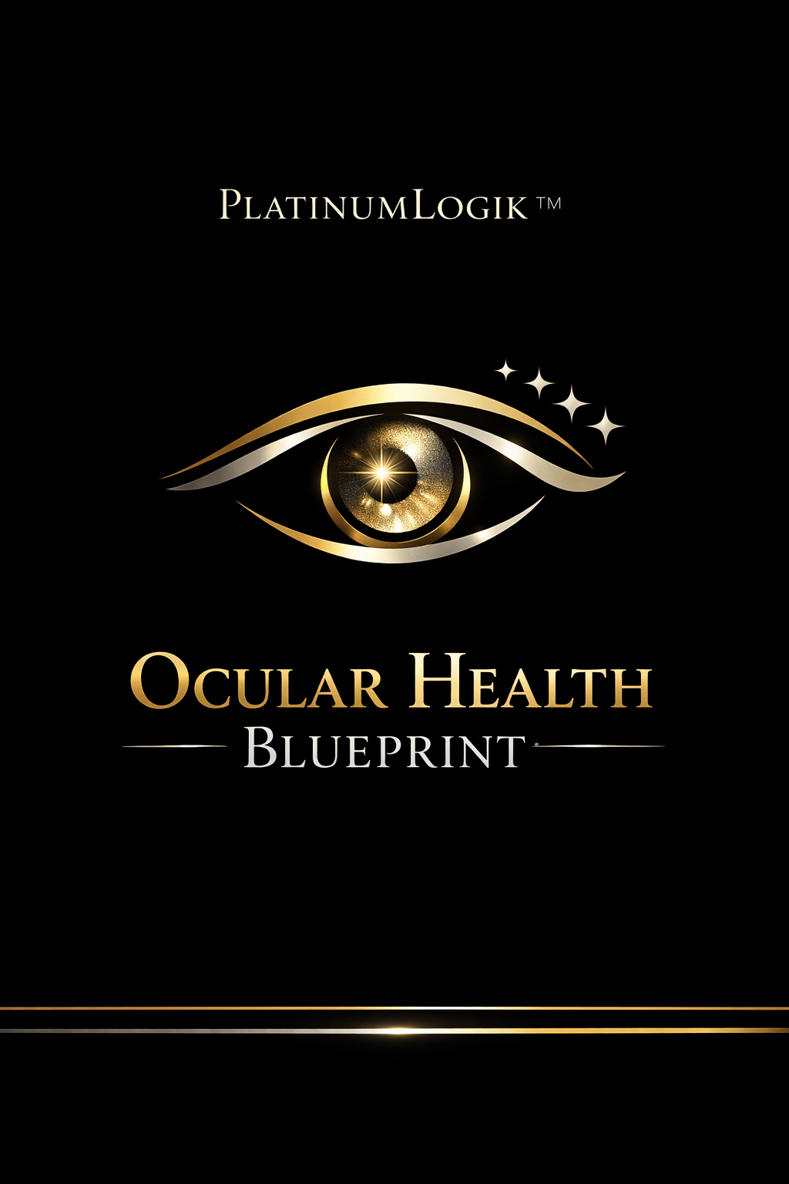
PlatinumLogik™ Ocular Health Blueprint
Food + supplementation options + natural methods for vision support and brighter-looking eyes

Blueprint Chapters
The Eye Pigments: Lutein + Zeaxanthin
Daily greens + fat combo: spinach/kale/collards/romaine/broccoli + olive oil/eggs/avocado/nuts.
Vitamin A + Carotenoids
Orange foods 4–5 days/week (carrots/sweet potato/pumpkin) + greens daily.
Omega‑3s
Fatty fish 2–3 times/week (salmon/sardines/mackerel/trout) + daily nuts/seeds.
Vitamins C + E
Citrus/kiwi/berries/peppers + almonds/sunflower/avocado.
Minerals
Zinc/selenium via seafood, pumpkin seeds, legumes, eggs, nuts.
“Whiter Whites” Support
Lower irritation: hydration + omega‑3 + greens + screen breaks + full blinking + sleep consistency; minimize smoke exposure.
Supplement Options (Optional)
Lutein+zeaxanthin; omega‑3; C/E; zinc; AREDS2-style blends (with copper).
Natural Daily Methods
Hydrate early; 20/20/20; full blink sets; UV-blocking sunglasses; avoid overly dry air; steady sleep.
Quick Start: 7-Day Menu
Use the Jumpstart plan or mix-and-match from the cookbook.

